**BASS DIFFUSION MODEL**

WHAT ARE WE DOING?

* ACTUAL VS. PREDICTED SALES PER QUARTER
* ACTUAL VS. PREDICTED CUMMILATIVE SALES PER QUARTER

It can be seen in the graph that it is a line graph. The trends are represented as sales and Psales on y axis and T on x axis. We can see two lines on the chart:

- The orange line shows the actual sales numbers, which go up and down a lot from quarter to quarter.

- The blue line shows the predicted sales, which moves smoothly and provides a steady forecast.

Link- <https://public.tableau.com/views/actualvs_predictedsales/Sheet1?:language=en-US&publish=yes&:sid=&:redirect=auth&:display_count=n&:origin=viz_share_link>

Code embedded-

<div class='tableauPlaceholder' id='viz1721351788344' style='position: relative'><noscript><a href='#'><img alt='Actual vs. Predicted Sales Per Quarter. Ankita Vashishtw0854392 ' src='https:&#47;&#47;public.tableau.com&#47;static&#47;images&#47;ac&#47;actualvs_predictedsales&#47;Sheet1&#47;1_rss.png' style='border: none' /></a></noscript><object class='tableauViz' style='display:none;'><param name='host_url' value='https%3A%2F%2Fpublic.tableau.com%2F' /> <param name='embed_code_version' value='3' /> <param name='site_root' value='' /><param name='name' value='actualvs_predictedsales&#47;Sheet1' /><param name='tabs' value='no' /><param name='toolbar' value='yes' /><param name='static_image' value='https:&#47;&#47;public.tableau.com&#47;static&#47;images&#47;ac&#47;actualvs_predictedsales&#47;Sheet1&#47;1.png' /> <param name='animate_transition' value='yes' /><param name='display_static_image' value='yes' /><param name='display_spinner' value='yes' /><param name='display_overlay' value='yes' /><param name='display_count' value='yes' /><param name='language' value='en-US' /><param name='filter' value='publish=yes' /></object></div> <script type='text/javascript'> var divElement = document.getElementById('viz1721351788344'); var vizElement = divElement.getElementsByTagName('object')[0]; vizElement.style.width='100%';vizElement.style.height=(divElement.offsetWidth*0.75)+'px'; var scriptElement = document.createElement('script'); scriptElement.src = 'https://public.tableau.com/javascripts/api/viz_v1.js'; vizElement.parentNode.insertBefore(scriptElement, vizElement); </script>

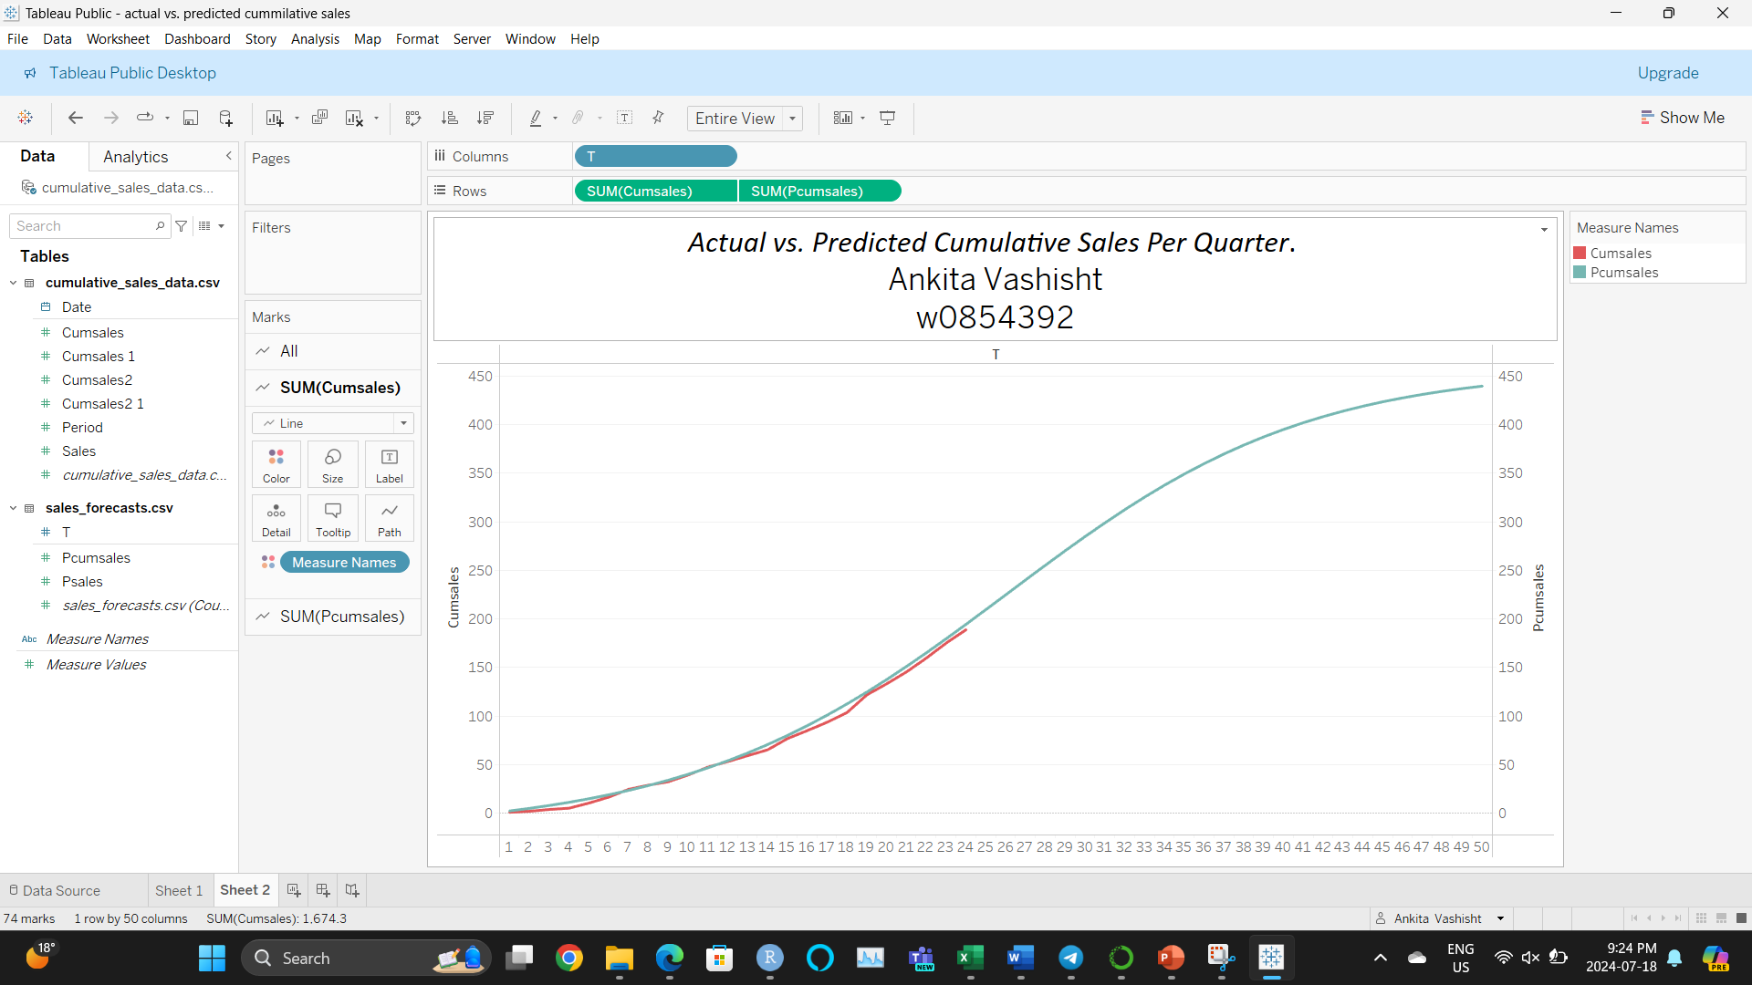

It can be seen in the graph that it is a line graph. The trends are represented as Cumsales and Pcumsales on y axis and T on x axis. Even though the actual cumulative sales numbers change smoothly, the predicted sales line closely follows them, providing a clear and accurate forecast of the total sales over time.

Link- <https://public.tableau.com/views/actualvs_predictedcummilativesales/Sheet2?:language=en-US&publish=yes&:sid=&:redirect=auth&:display_count=n&:origin=viz_share_link>

Code embedded- <div class='tableauPlaceholder' id='viz1721352352947' style='position: relative'><noscript><a href='#'><img alt='Actual vs. Predicted Cumulative Sales Per Quarter. Ankita Vashishtw0854392 ' src='https:&#47;&#47;public.tableau.com&#47;static&#47;images&#47;ac&#47;actualvs_predictedcummilativesales&#47;Sheet2&#47;1_rss.png' style='border: none' /></a></noscript><object class='tableauViz' style='display:none;'><param name='host_url' value='https%3A%2F%2Fpublic.tableau.com%2F' /> <param name='embed_code_version' value='3' /> <param name='site_root' value='' /><param name='name' value='actualvs_predictedcummilativesales&#47;Sheet2' /><param name='tabs' value='no' /><param name='toolbar' value='yes' /><param name='static_image' value='https:&#47;&#47;public.tableau.com&#47;static&#47;images&#47;ac&#47;actualvs_predictedcummilativesales&#47;Sheet2&#47;1.png' /> <param name='animate_transition' value='yes' /><param name='display_static_image' value='yes' /><param name='display_spinner' value='yes' /><param name='display_overlay' value='yes' /><param name='display_count' value='yes' /><param name='language' value='en-US' /><param name='filter' value='publish=yes' /></object></div> <script type='text/javascript'> var divElement = document.getElementById('viz1721352352947'); var vizElement = divElement.getElementsByTagName('object')[0]; vizElement.style.width='100%';vizElement.style.height=(divElement.offsetWidth*0.75)+'px'; var scriptElement = document.createElement('script'); scriptElement.src = 'https://public.tableau.com/javascripts/api/viz_v1.js'; vizElement.parentNode.insertBefore(scriptElement, vizElement); </script>